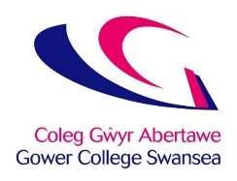

How to Make a Complaint

Let us know!

The College is committed to providing you with an excellent service and welcomes feedback to help us continually improve your experience at the College.

How to Make a Complaint

If you have a complaint your personal tutor can help you resolve the issue and you should discuss it with them

If that is not possible or if you are not satisfied with the outcome then you can submit your complaint via the Quality Unit to the Director of Quality and Curriculum in the following ways:

- in writing either by letter (address for the attention of the Quality Unit and hand it in to reception) or email (Beverley.hunt@gowercollegeswansea.ac.uk)
- in writing using the Compliments, Complaints and Suggestions form (available at all Reception areas)
- verbally in person or by telephone if support is required to put the complaint in writing:

o 01792 284000 - Tycoch
o 01792 890700 - Gorseinon
  - 01792 284021 – Llwyn y Bryn
  - 01792 284400 – Jubilee Court
  - 01792 284011 – Sketty Hall

If you need support in making your complaint you can bring someone with you e.g. tutor, outside agency, translator, etc.

What happens next?

The Director of Quality and Curriculum will refer the complaint for investigation – this will normally be carried out by a senior member of staff.

If a group of learners have complained the person carrying out the investigation may meet with the full group of learners to ensure all views are fairly represented.

You will receive a written response to the complaint within three weeks and will also be told how to appeal if you disagree with the outcome.

The full complaints policy including information on appeals is available on the College website.

